 | Curriculum Vitae
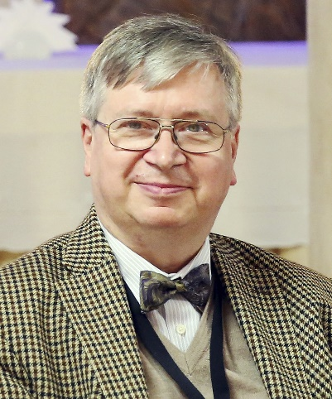 | C.-Andreas Dalluege
 | Born: 5. January 1955
 | Qualification
- Dipl.-Kfm.
- EFQM Certified Advisor & Trainer
- ILEP Licensed Trainer & ILEP Operating Partner
- CAF Assessor & Assessor for Project Excellence Award (GPM & IPMA)
 | Present function
 | - Managing Partner of IBK Management Solutions GmbH
- Owner of IBK – Institut für Betriebsanalyse und Kommunikationsforschung
- President of European Business Excellence Network (EuroBEN)
- National Council Member of the Institute of Industrial Engineering and Safety Management Systems (IIESMS)
Key competence | - EFQM European Excellence Award Assessor & Validator (since 2003)  - CAF Assessor & Project Excellence Award Assessor  - Operating Partner for ILEP (Initiative Ludwig-Erhard-Preis)  - EFQM and ILEP Licensed Trainer since 2013  - introduction of EFQM Excellence Model in educational and training  organisations, public administration, SME & Industry  - strategic management coach  - management process design and re-engineering  - design and implementation of sector or task specific self-assessment solutions
Country experiences | Albania, Austria, Belgium, Denmark, Ecuador, Finland, Germany, Ireland, Italy, Jordan, Latvia, Liechtenstein, Netherlands, Romania, Spain, Switzerland, Soviet Republic, Turkey, United Arabian Emirates and United Kingdom
Publications | 7 books on management methodologies (with 4 on EFQM, the one on Excellence in Education now in its 4th printing)
Languages | German (native speaker)  - English (fluently)  - French (acceptable)
Computer literacy | All Microsoft Office programmes + CorelDRAW Suite & GOA-WorkBench

Work history
since 2020 | Board Member of the Irish Work Study Institute (IIESMS)
since 2002 | Managing Partner of IBK Management Solutions GmbH
since 2010 | Guest Lecturer as several universities (Barcelona, Karlsruhe, Pristina)
since 1983 | Founder & owner of IBK - Institut für Betriebsanalyse und Kommunikationsforschung
2010 - 2015 | Senior Partner in G4E – Go for Excellence Ltd. Riga
1987 - 2002 | Managing Partner of IBK System- & Softwarehaus GmbH
1994 - 2001 | Non-executive Board Director of ISD-Holding (PT sister company to IBK)
1978 - 1982 | Founding Partner in TBD Electronics GbR

EU Research Project Activities
since 2022 | Representing IBK in an EU4Health project dealing with further education in the medical and health care sector in Europe with a focus on skills development for digital transformation and sustainability
since 2019 | Representing IBK in five ERASMUS projects one on Digital Transformation, two Stress Management and one on Work-Life-Flow, all with a special focus on Sustainability and business Excellence
2011 - 2016 | Running five projects on Excellence in Education in the Leonardo da Vinci Programme in one of them acting as the formal coordinator, responsible against CEC/NA.
2002-2010 | Supporting eight EU Projects on TQM/EFQM with sector specific GOA-WorkBench adaptations, in two of them additionally subcontracted to manage and lead the projects.
1989 - 2002 | Representing either IBK-Group or ISD-Holding in 20 European Research Projects from a range of programmes: ESPRIT, ESSI, , Innovation, MEDIA II, SPRINT, TEN/Telecom & Value

Other Projects & Trainings
Since 2019 | Guest Lecturer at TH Aschaffenburg on the topics Business Excellence und EU Project Management
Autumn 2018 | Project Evaluator for DIES at GJU
Since 2014 | Visiting Lecturer at University for Business and Technology (Pristina) for regular classes on Business Excellence
Since 2013 | EFQM Licensed Trainer and accredited trainer for ILEP
Since 2011 | Operating Partner for ILEP (Initialive Ludwig Erhard Preis)
Since 2010 | Guest Lecturer for two Universities in Germany and Spain (Karlsruhe, Barcelona)
since 2009 | Coach and Excellence Trainer to Südwestmetall (entrepreneurs association of ~ 1.000 companies of the metal and electronics industries of south-west Germany) for promoting and implementing EFQM in all its member companies
since 2003 | Regularly active assessor for EFQM in the European Award and the EFQM Recognition Scheme with assignments within Austria, Germany, Hungary, Italy, Russia, Scotland, Spain, Turkey and Wales
Since 1999 | Representative of IBK to the EFQM
Since 1993 | Founder and President of the European Association for Information and Communication (EAI&K e.V.), later renamed EuroBEN (European Business Excellence Network)
Since 1988 | Free lancing journalist for Artificial Intelligence, Decision Support Systems, Office Automation and Total Quality Management topics with regular publications in leading business magazines
1986 - 1994 | Board member of Bavarian Chapter of BVWM (National Association of SME)

Academic Education
1983-1986 | Post graduate studies in Communication Sciences and Organisational Psychology at LMU
1983 | Master level diploma in management sciences (Dipl.-Kaufmann) from LMU
1977-1982 | Management Sciences (BWL) at Ludwig-Maximilian University München (LMU)
1974-1976 | Electronics Engineering at TU München
Last update: | Wiesbaden, 6/10/2021

